Changing PRO-view cameras to DHCP

- Download our IP Camera search tool from the link below and install
https://drive.google.com/open?id=0B9Cfm4XKkkp8alRCY3BFUlZoYlU
- Connect a laptop into a numbered port on the NVR. You may need to remove a camera.

- Once everything is connected, run the IP camera search tool on your laptop and click search at the bottom. This should show all the connected cameras.
If this shows no cameras, plug your laptop into the LAN on the NVR
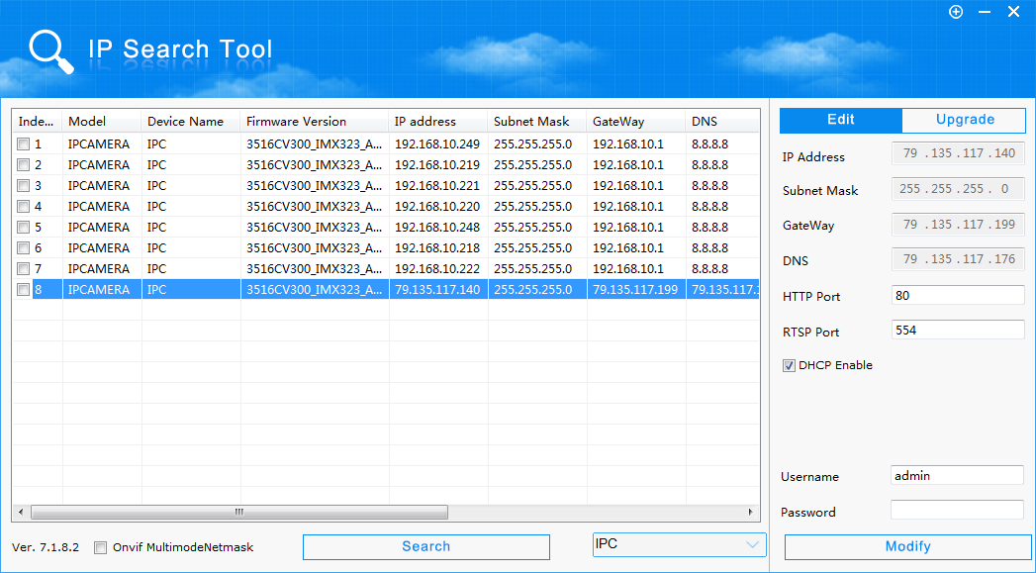
- Select the camera you want to make DHCP, on the right hand side tick the “DHCP Enable” box then enter the username and password.
Username: admin
Password: admin
Once entered, press modify and a box will pop up saying “Modify Success”, this will reboot the camera. Once done, it will now be on a DHCP address and display on screen.

