Changing PRO-view cameras from DHCP to static

- Download our IP Camera search tool from the link below and install
https://drive.google.com/open?id=0B9Cfm4XKkkp8alRCY3BFUlZoYlU
- Once everything is connected, run the IP camera search tool on your laptop, select “IPC” from the dropdown box that says “All” then click “Search” and it should pick up the cameras as below.
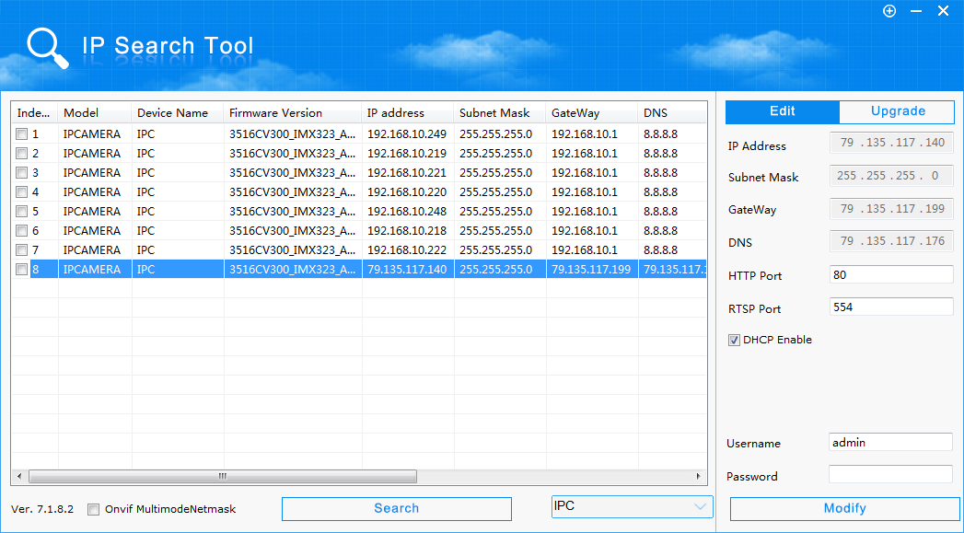
- Select the camera you want to make static, on the right hand side untick the “DHCP Enable” box then enter the username and password.
Username: admin
Password: admin
Once entered, press modify, this may reboot the camera. Once done, it will now be on a static address.
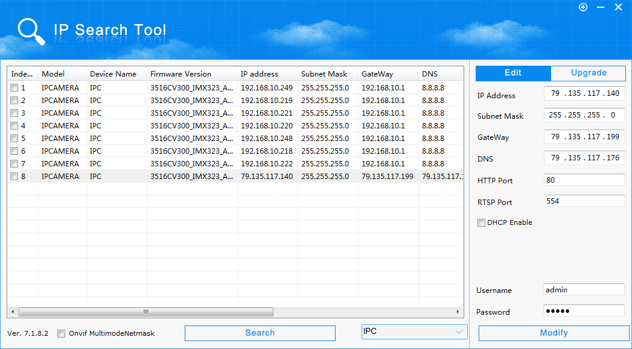
Example static IP Address
IP Address: 192.168.1.118
Subnet Mask: 255.255.255.0
Gateway: 192.168.1.x (Find this out on site / from client. It will be 1.1 or 1.254)
DNS. 8.8.8.8
HTTP Port: 80
RTSP Port: 554

