Changing H265 to H264 using the DVR
A camera which is in H265 will look like this shortly after fully powering (Channel 7 & 8). It will just be a blue square without the video loss and down at the bottom will display a black squared monitor instead of the red lines to show video loss.
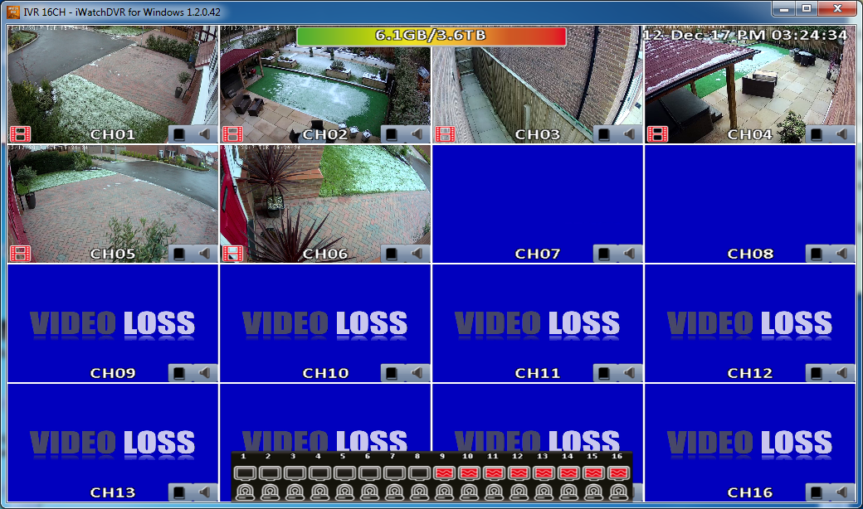
Right click, go to “Configure”, then “Camera Setup” and choose the camera which is struggling to pull through the image. Camera 7 in this example.
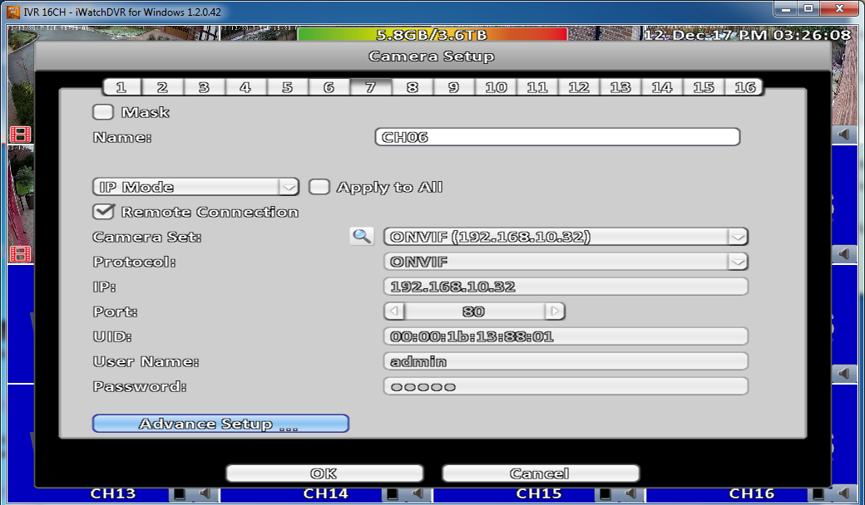
Once on here, select “Advance Setup” in the bottom left.
You will now see the resolution options for the camera. If you select the dropdown, you will see multiple. If in H265, it should be on 2304x1296, select this and change it to 1920x1080 then press apply at the bottom. This should then display the camera image.
